Supporting Information: Increasing the length of polypyrimidine bulges leads to broader RNA conformational ensembles while minimally impacting coaxial stacking energetics

Dawn K. Merriman¹, Jiayi Yuan^{1,2}, Honglue Shi¹, Daniel Herschlag³ and Hashim M. Al-Hashimi *^{1,4}

¹ Department of Chemistry, Duke University, Durham, North Carolina 27708

²Department of Biology, Duke University, Durham, North Carolina 27708

³Department of Biochemistry Stanford University, Stanford, CA 94305
⁴Department of Biochemistry, Duke University Medical Center, Durham, North Carolina 27710
*To whom correspondence should be addressed: hashim.al.hashimi@duke.edu
Telephone: (919) 660-1113

SI Discussion: A base triple may bias the U₂TAR ensemble toward the stacked state
To further examine the unusual behavior of U₂TAR, we surveyed crystal structures of all one, two, and three nt bulges in the protein databank (Berman et al. 2000) (see methods). When considering all entries, in general, we observe the expected trend, in which longer bulge motifs tend to have larger bend angles (|β_{h}|) (SI Fig 7B, left). Removing entries that feature RNA bound to proteins, skews the distribution toward smaller bend angles (|β_{h}| < 45°), with the exception of a few outliers involving tertiary contacts (Robertson et al. 2005) (SI Fig 7B, middle). Interestingly, when filtering for both free RNA containing polypyrimidine sequence, we see enrichment of two nt bulge motifs with more coaxial conformations with bend angle ~ 10° similar to that observed here for U₂TAR (SI Fig 7B, right). Notably, five out of the six entries include four U•A•U and one C•G•C involving the 5'-bulge nucleotide and the second Watson-Crick base pair 3' to the bulge, which are known to stabilize coaxial stacking (Durney and D’Souza 2010). Importantly, all TAR variants studied here, including U₂TAR, have sequences that support formation of U25-A27-U38 (refer to Figure 2A). Indeed, this base triple is thought to be a key feature of the functional state of TAR when bound to Tat (Brodsky and Williamson 1997; Hennig and Williamson 2000; Puglisi et al. 1992). Transient formation of this base triple may be optimal in U₂TAR, as it could restrict the inter-helical flexibility while retaining enough wiggle room to form the base triple.
To examine this possibility, we analyzed 2D NOESY spectra of U₂TAR (SI Fig 7A). Indeed, we found an intense G26-H8-U23-H1' and G26-H8-A22-H1' and weak G26-H8-U25-H1' NOE cross peaks translating to distances of 3.7±0.3 Å from U23-H1', 4.3±0.3 Å from A22-H1', and 4.0±0.3 Å from U25-H1'. These NOEs have been used in the past to suggest base triple formation in TAR bound to argininamide (Puglisi et al. 1992). As observed in TAR bound to argininamide, no imino resonance was observed between U23 and A27, suggesting the base triple is transiently formed. Thus, to provide further support for a base triple formation we corroborated the NOE derived distances with a 3.5 ms molecular dynamic simulation (see methods). During the simulation the NOE between U23-H1' and G26-H8 is only predicted to occur if U23 is forming a base triple with A27•U38 (SI Fig 7C-E). Note that spectral overlap of key resonances prevented assessment of the base triple formation in the presence of Mg²⁺.

Figure 1: Chemical shift mapping of TAR bulge variants at 25 mM NaCl and 25 mM NaCl with 3 mM Mg²⁺. For assignments of bulge variant chemical shifts, see methods. (A) Chemical shift overlays of wtTAR and bulge variants at 25 mM NaCl. Assignments marked with an asterisk are ambiguous and should be interrupted with caution. See inset for legend. (B) Chemical shift perturbations in ¹H and ¹³C for each resonance in common between wtTAR and bulge mutants at 25 mM NaCl and (C) 25 mM NaCl with 3 mM Mg²⁺ (see inset for legend). Inset are the populations and corresponding ΔG values based upon the U23 chemical shift (see methods).

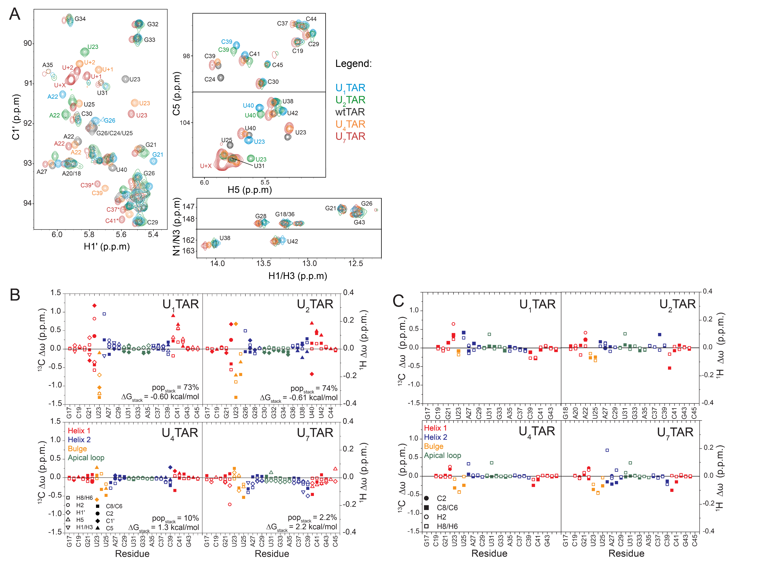

Figure 1 continued: (D) SOFAST-HMQC (Sathyamoorthy et al. 2014) overlays of Mg²⁺ titration on TAR variants at 25 μM [RNA], (E) wtTAR in buffer without EDTA, and (F) wtTAR with at 0.3 mM [RNA]. See inset for legend of Mg²⁺ concentrations.

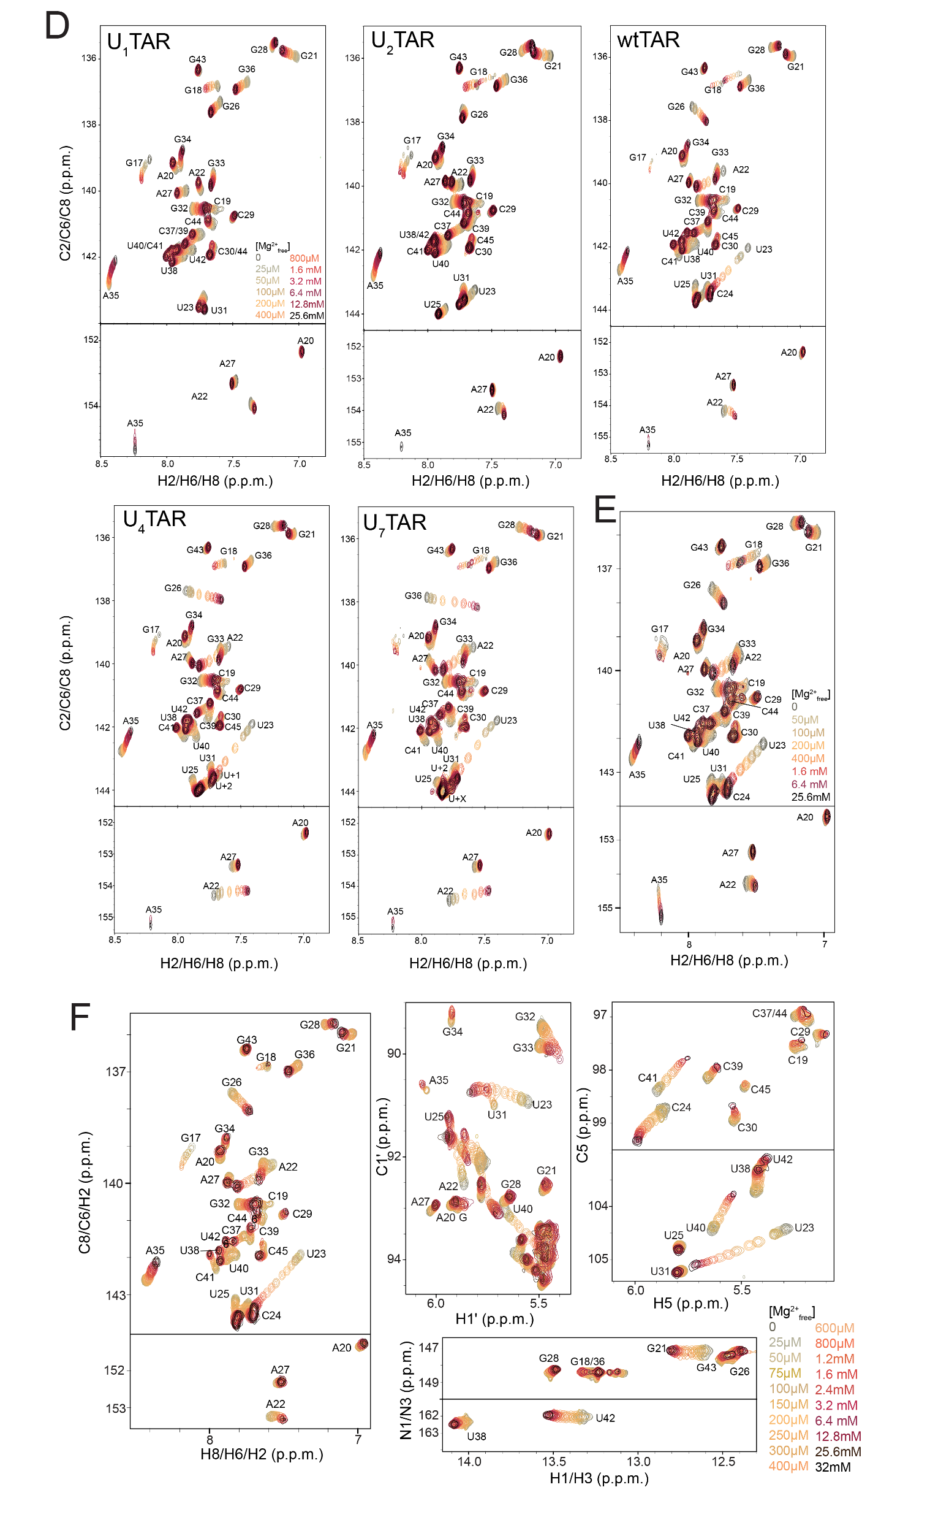
Figure 2: Normalized peak intensities of TAR bulge variants. (A) Normalized peak intensities at 25 mM NaCl and at 25 mM NaCl with [Mg²⁺] of 0 (bottom), 3 mM (middle) and 25.6 mM (top) with helix 1 (red), helix 2 (blue), bulge (orange) and apical loop (green) resonances shown with C8H8/C6H6 (square), C2H2 (circle), C5H5 (triangle), C1'H1' (diamond), and N1H1/N3H3 (upside down triangle) normalized to 0.1 (see methods for normalization).

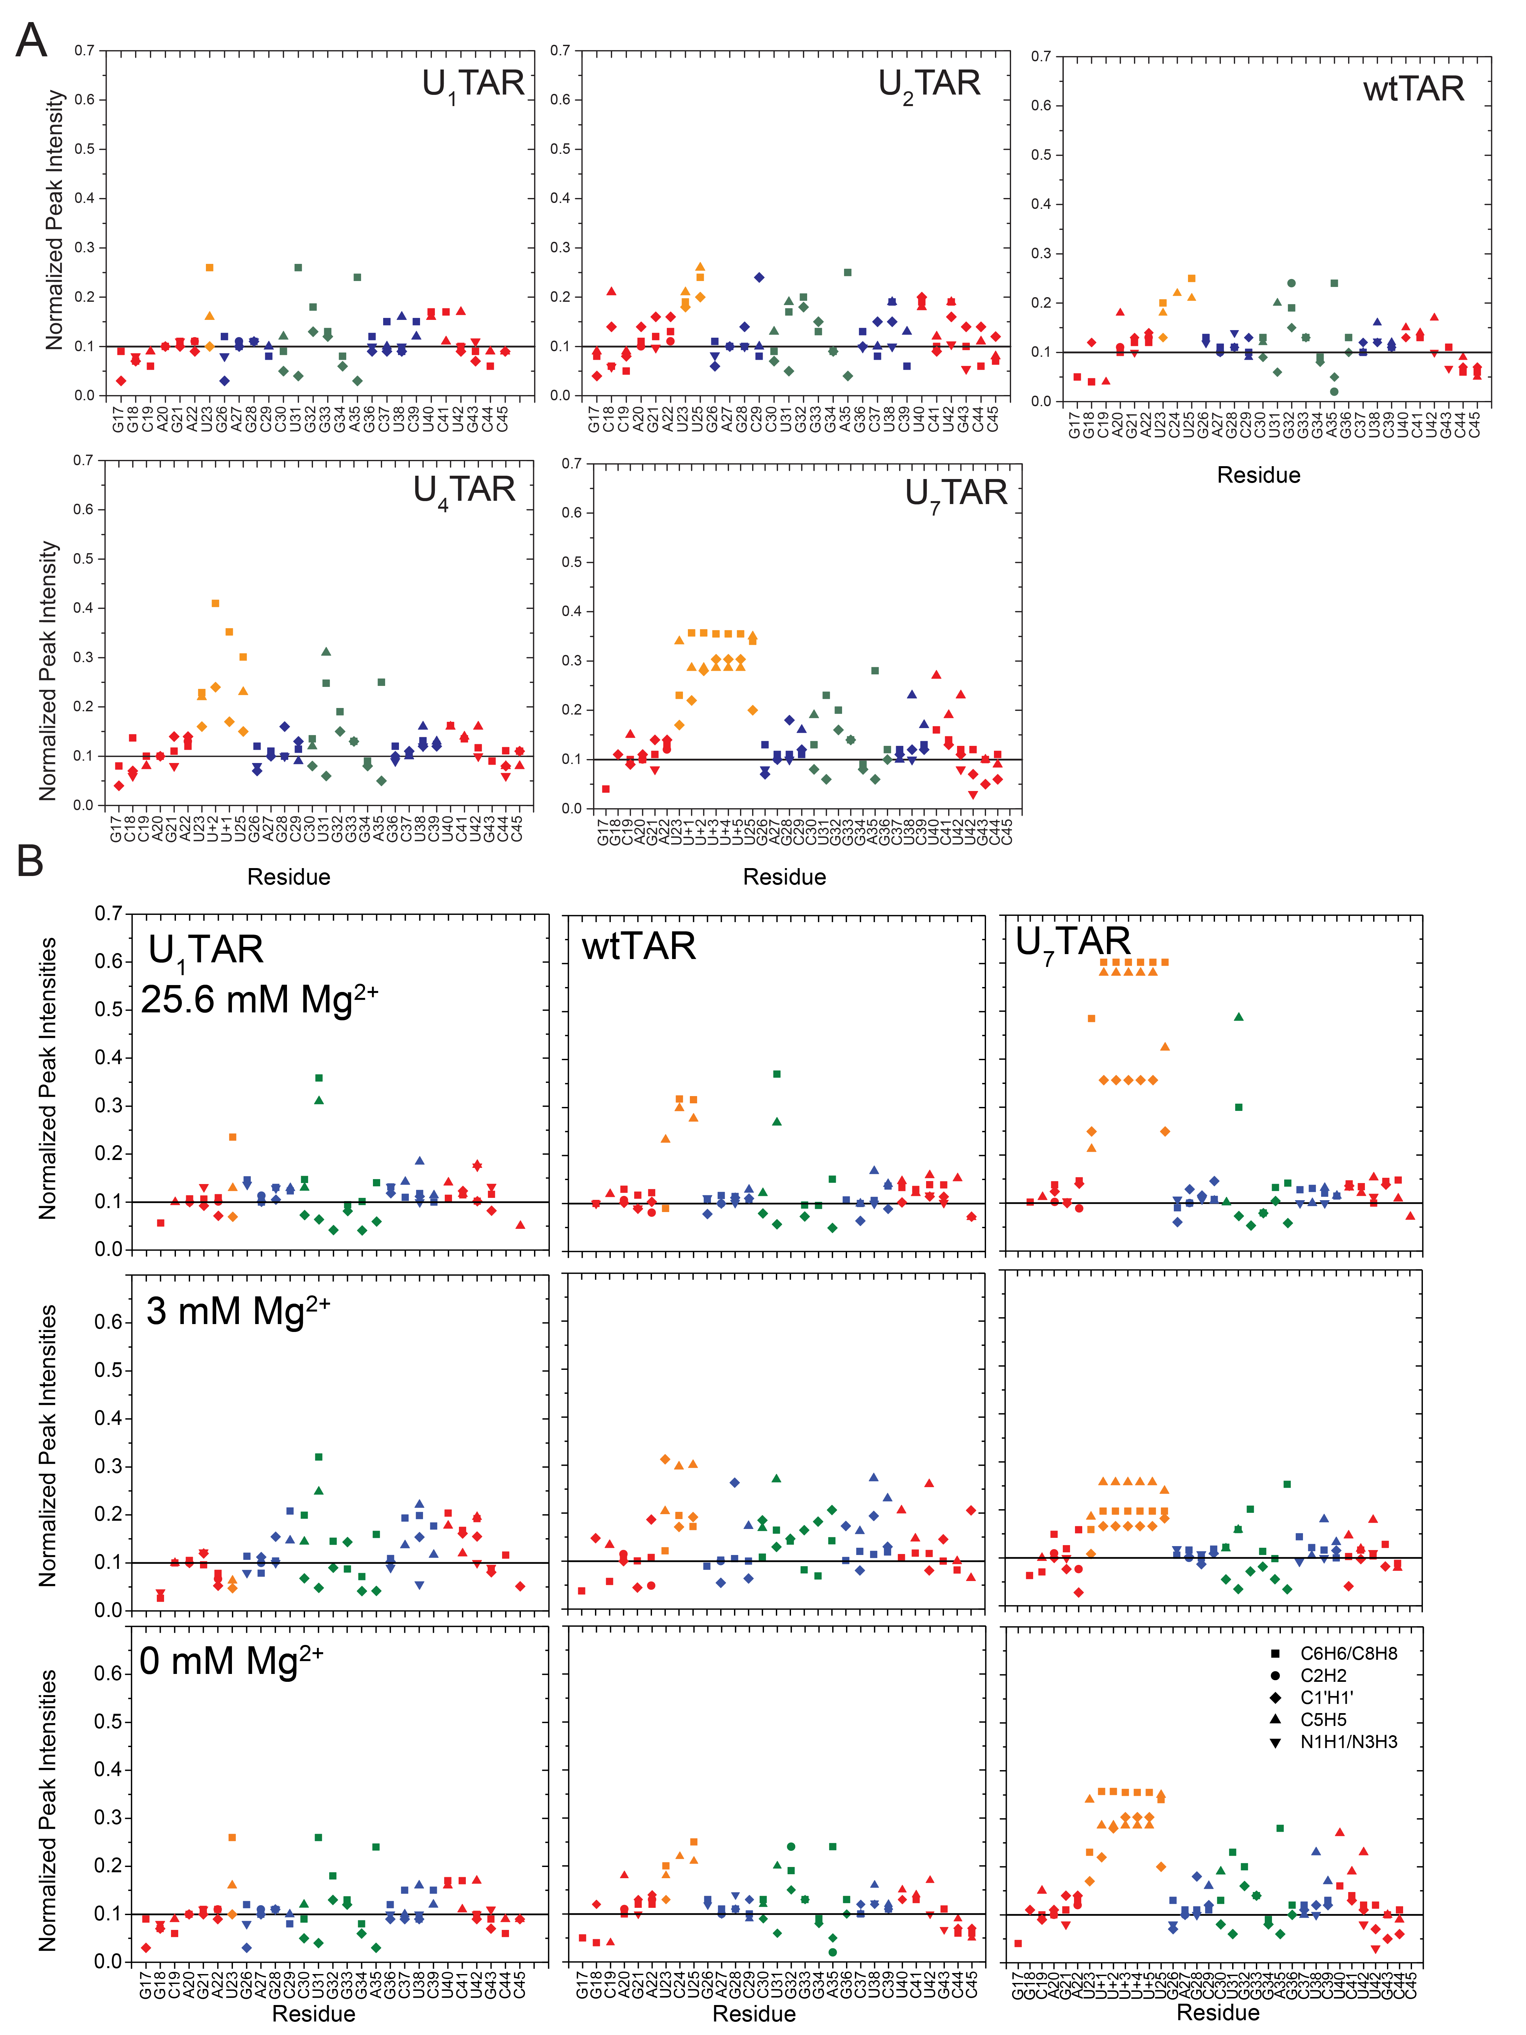
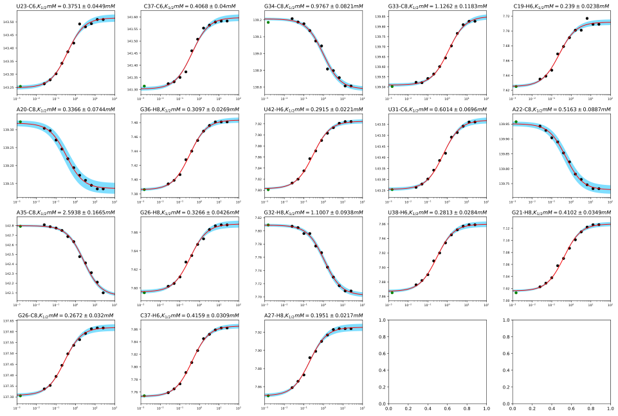
Figure 3: Mg_{1/2} measurements for (A) U₁TAR, (B) U₂TAR, (C) wtTAR, (D) U₄TAR, (E) U₇TAR (F) wtTAR without EDTA, and (G) 0.3 mM wtTAR. Green points represent when [Mg²⁺] = 0, and blue bands represent σ₁ error bands as determined by 2,000 rounds of standard Monte Carlo error estimation (see methods).
A
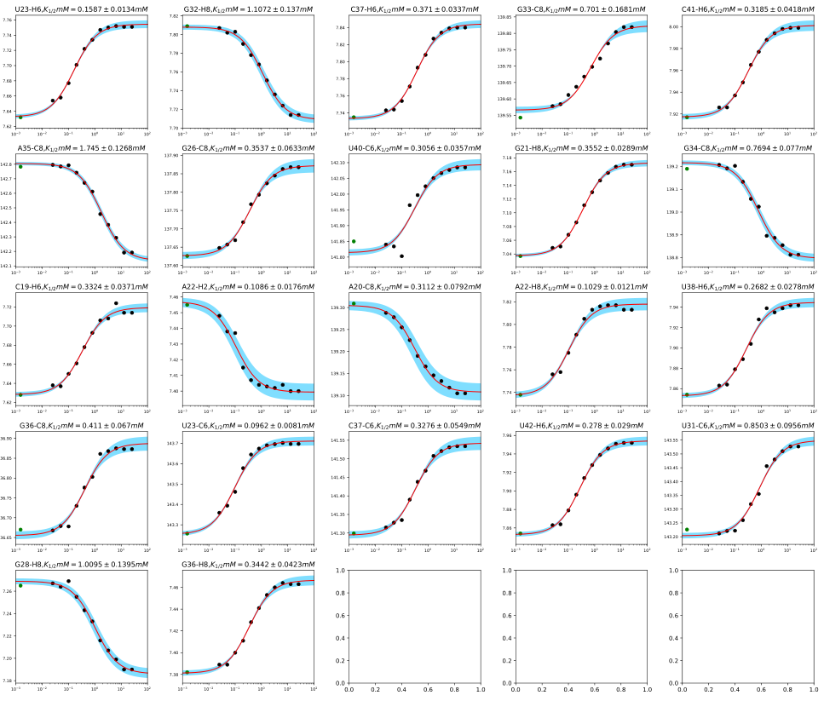
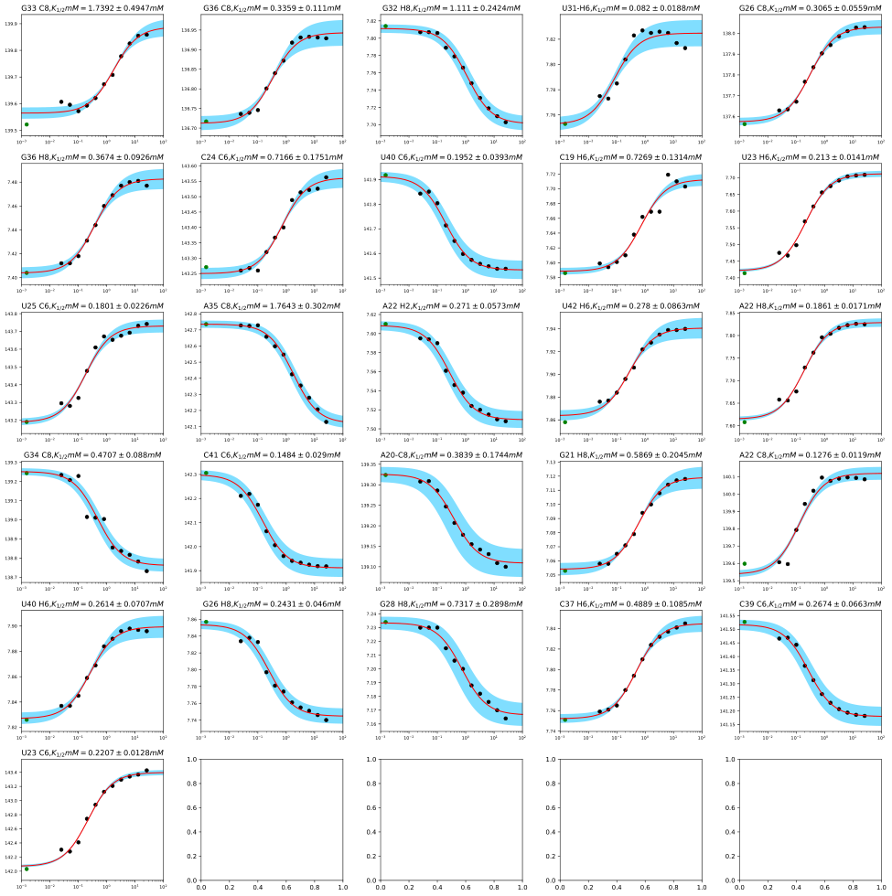
Figure 3 continued: Mg_{1/2} measurements for U₂TAR
Figure 3 continued: Mg_{1/2} measurements for wtTAR
B
C
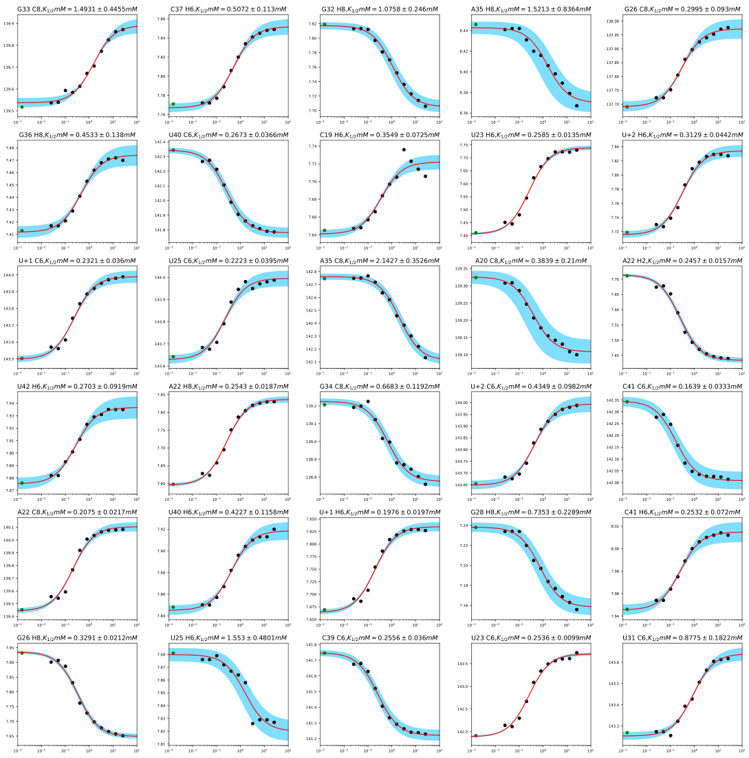
Figure 3 continued: Mg_{1/2} measurements for U₄TAR
D
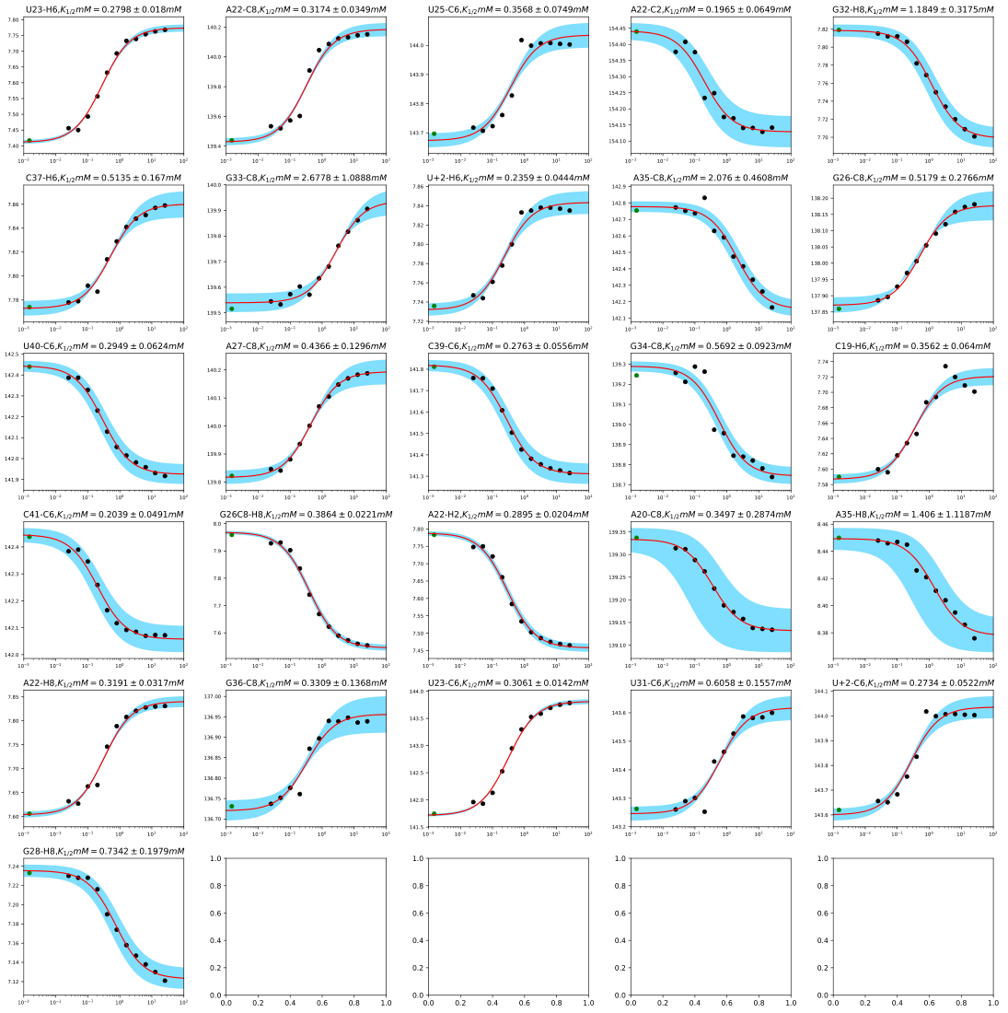
Figure 3 continued: Mg_{1/2} measurements for U₇TAR
E
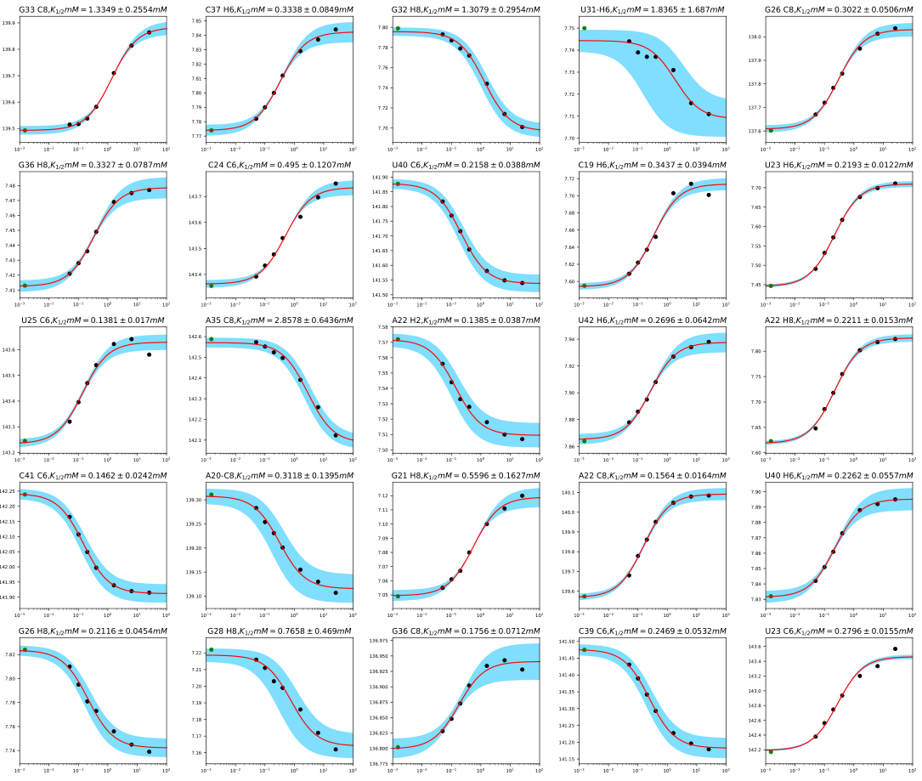
Figure 3 continued: Mg_{1/2} measurements for wtTAR in the absence of EDTA
F
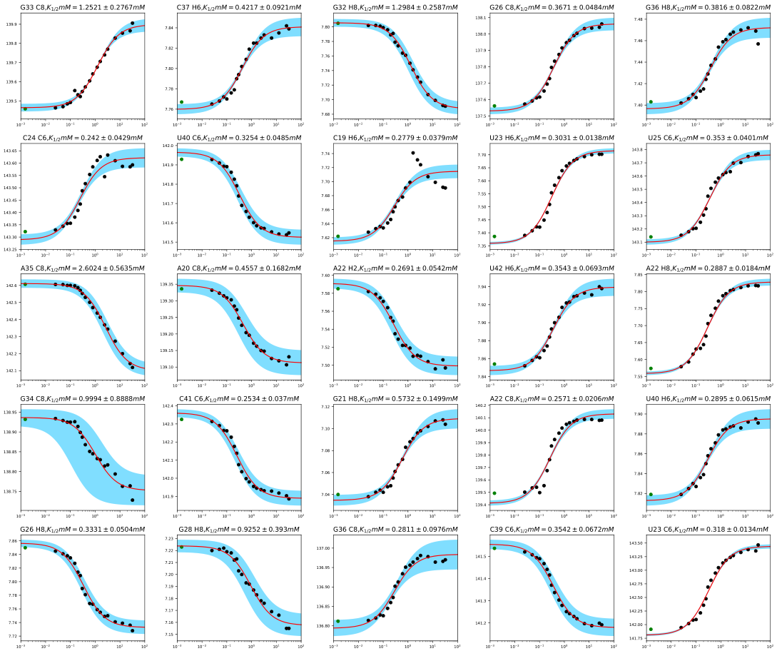
Figure 3 continued: Mg_{1/2} measurements for wtTAR at 0.3 mM [RNA]
G

Figure 4: Two-site Mg²⁺ binding at U₂TAR A22-C8. Shown is the fit of the two-site binding equation with fitted Mg_{1/2} values. See Table 3 for all fitted parameters.

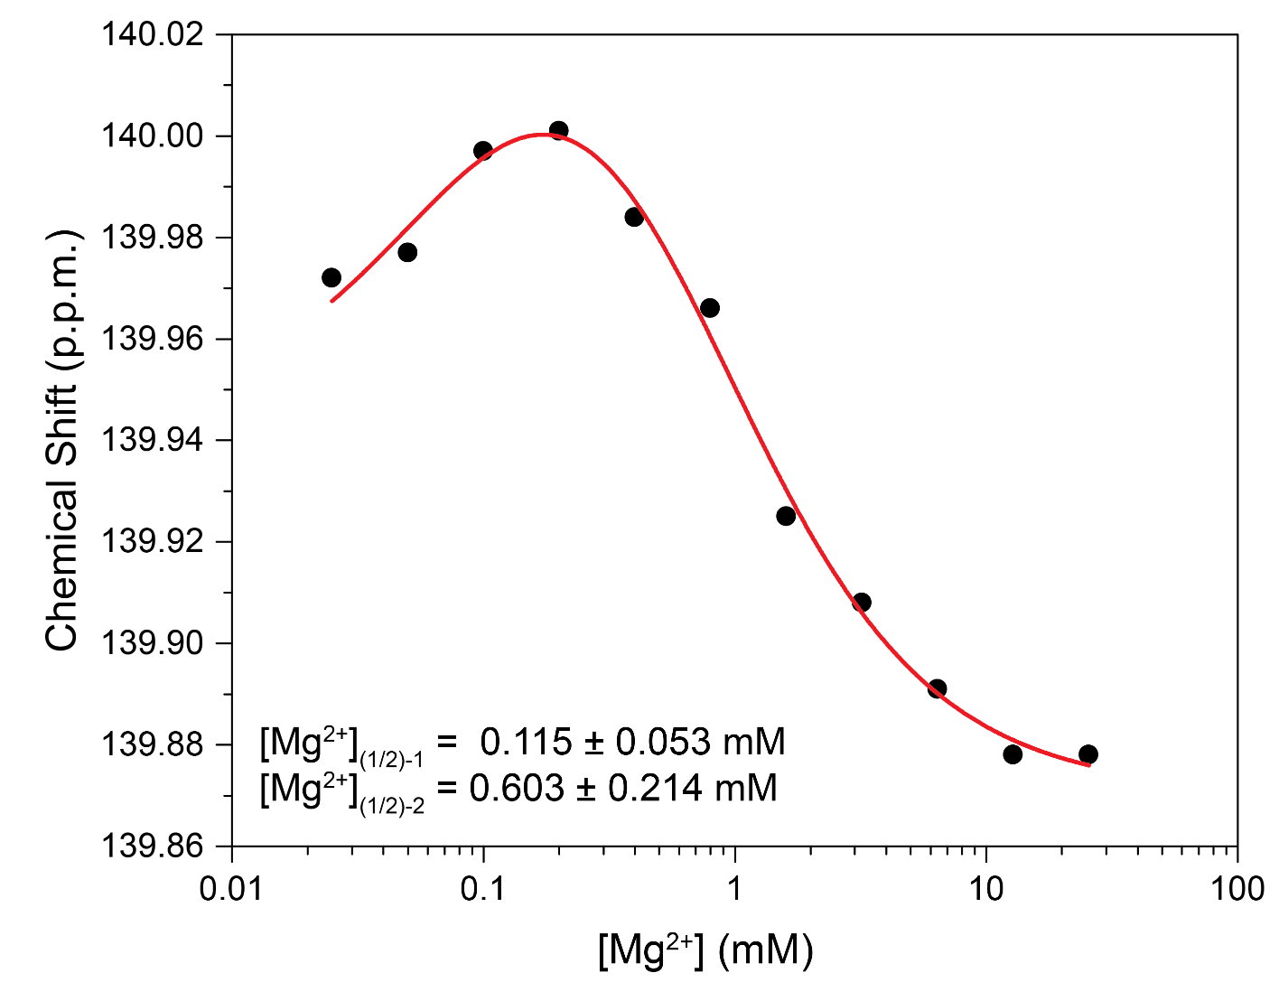

Figure 5: RDC measurements on TAR bulge variants. (A) RDCs measured in ¹H and ¹³C dimensions in 25 mM NaCl for U₁ and U₇TAR and 25 mM NaCl with 3 mM Mg²⁺ for U₁, wt, and U₇TAR, showing the R² correlation and RMSD between ¹H and ¹³C RDCs. See inset for legend. (B) Normalized RDC values as a function of secondary structure at 25 mM NaCl and (C) 25 mM NaCl and 3 mM Mg²⁺. RDCs were all normalized to wtTAR in the absence of Mg²⁺ to allow for facile comparison of all RDCs measured (see methods).

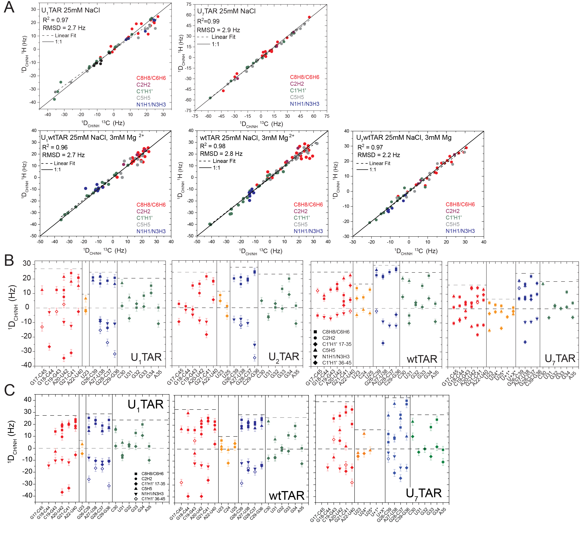

Figure 6: RAMAH analysis of TAR bulge variants. (A) Comparison of measured and back-calculated RDCs of helix 1 (red) and helix 2 (blue) for U₁TAR (left) and U₇TAR (right). (B) Alternative inter-helical structure for U₇TAR due to degeneracy of the order tensor analysis(Bailor et al. 2007). The yellow dotted line highlights the A22 (O3′) to G26 (P) distance which is within the range of a 7-nucleotide bulge. (C) Sanson-Flamsteed maps of order tensors for helix 1 (red) and helix 2 (blue) of TAR variants in 25 mM NaCl. (D) Comparison of measured and back-calculated RDCs and Sanson-Flamsteed of helix 1 (red) and helix 2 for U₁ (left), wt (middle) and U₇TAR (right) in 25 mM NaCl and 3 mM Mg²⁺.
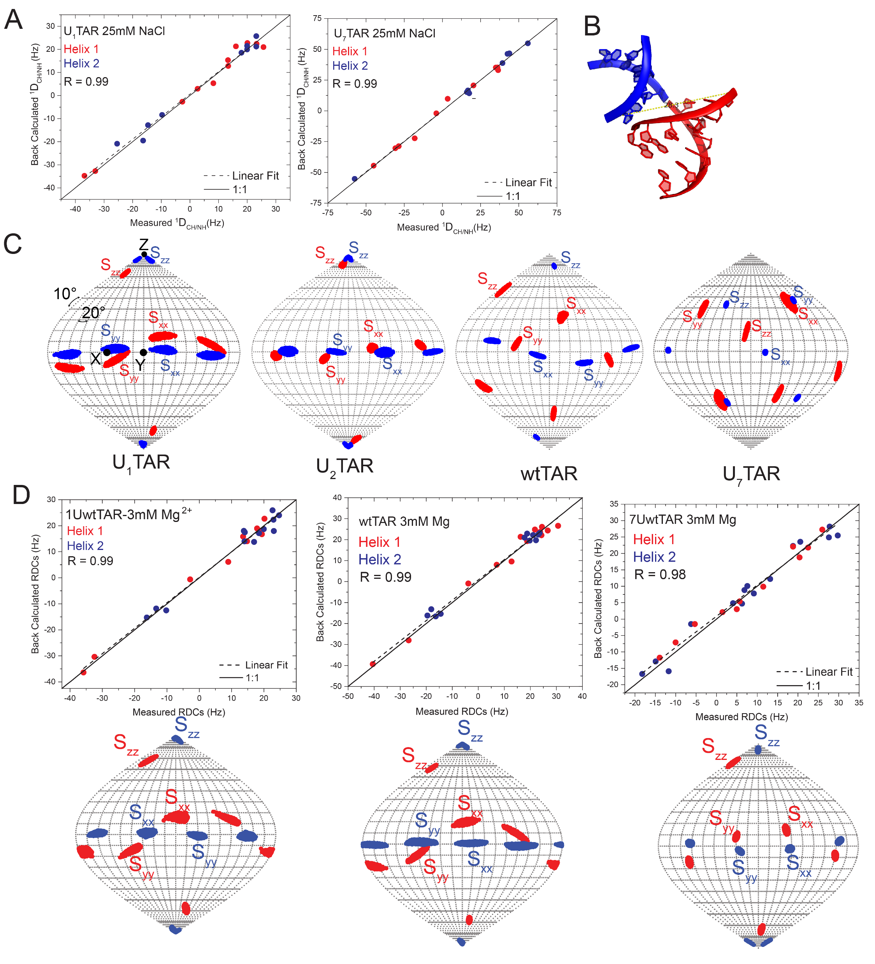

Figure 7. Evidence for a base triple in U₂TAR. (A) 2D NOESY spectrum of U₂TAR (right), showing sequential NOE-based connectivity (black lines) which are highlighted using a solid black line on the U₂TAR secondary structure (left, bottom). In red are the specific and unique NOEs observed, which are consistent with formation of an U23•A27•U38 base triple (Puglisi et al. 1992), along with the chemical structure of the base triple (left, top). (B) Inter-helical bend angles for one, two, and three nucleotide bulge motifs obtained from a survey of PDB (see methods). Values are shown for all entries (left), following exclusion of protein bound RNA i.e. free RNA (middle), and filtering free RNA to only include poly-pyrimidine bulges (right).

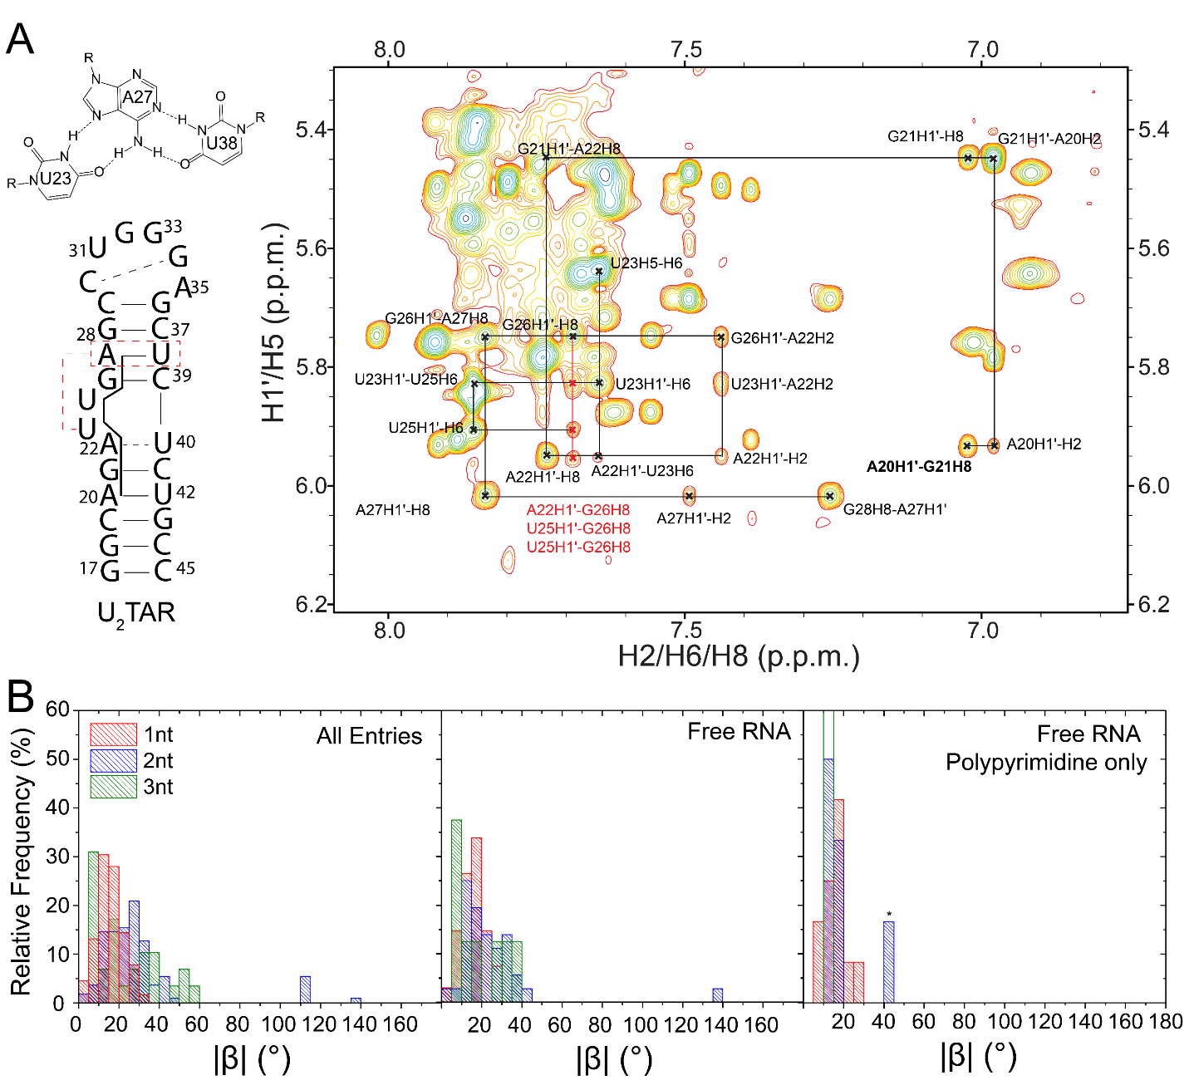

Figure 7 continued: (C) Distance measurements in Å of proton-proton distances for U23-H1'-G26H8 (left), U25H1'-G26H8 (middle), and A22H1'-G26H8 (right) over the course of the 3.5 ms simulation. Black lines highlight the NOE distance measured from the U₂TAR NOESY experiment (see methods). (D) Distance measurements between highlighting that an imino resonance may not be observed in the base triple due to the extended, and dynamic distance between U23H3 and A27-N7 (right) as compared to a stable Watson-Crick base pair imino between A20N1 and U42 H3 (left). (E) Example structures pulled during the simulation showing the measured interhelical angle (β) when the base triple is formed (left), broken (middle) and U23 flips into the helix (right), which zoomed in figures of the bulge to highlight the positioning of bulge residues. (F) H6(C5)NN NMR spectra (Pitt et al. 2004) of U₂TAR. For U₂TAR in (left) 25 mM NaCl and 5 mM Argininamide, (middle) 25 mM NaCl and (right) 25 mM NaCl and 3 mM Mg²⁺. Dotted lines connect U-N3 with A-N1/N7 resonances.
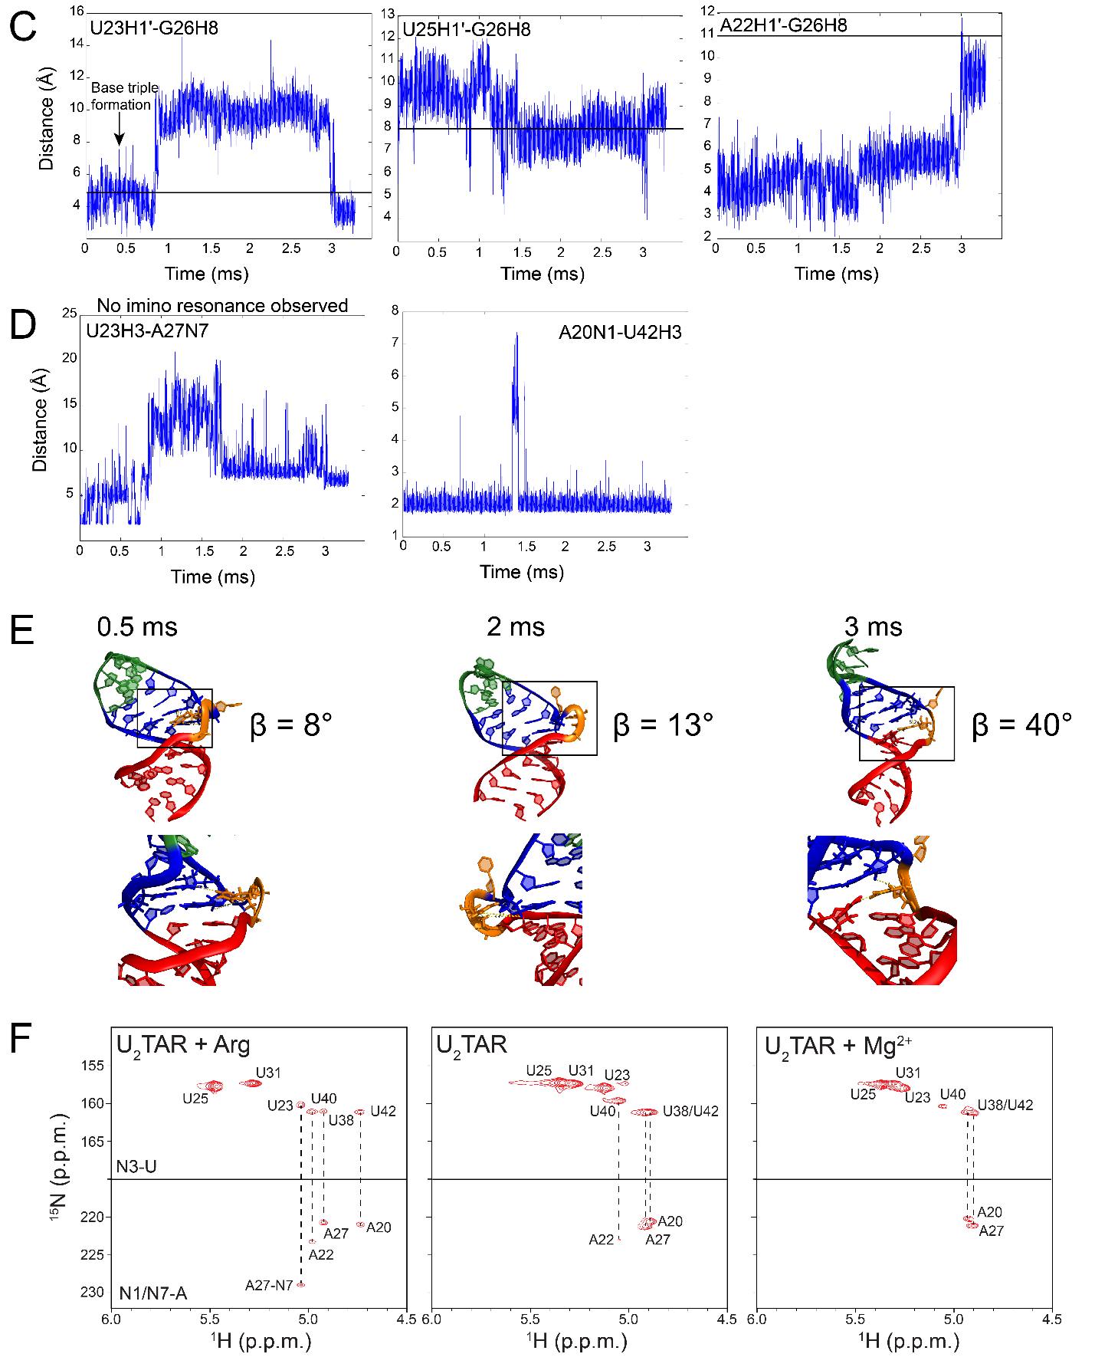
Figure 8: (A) N1H1, N7H7 HSQC overlays at [Mg²⁺] = 0 (black) and 25.6mM (red) for U₁ (left), wt (middle), U₇TAR (right) where arrows highlight large chemical shift perturbations from low (25 mM NaCl) to high (25 mM NaCl, 25.6 mM Mg²⁺) salt. (B) Chemical shift perturbations from low to high salt for U₁, wt, and U₇TAR for N1 and N7 chemical shifts. See inset for legend.

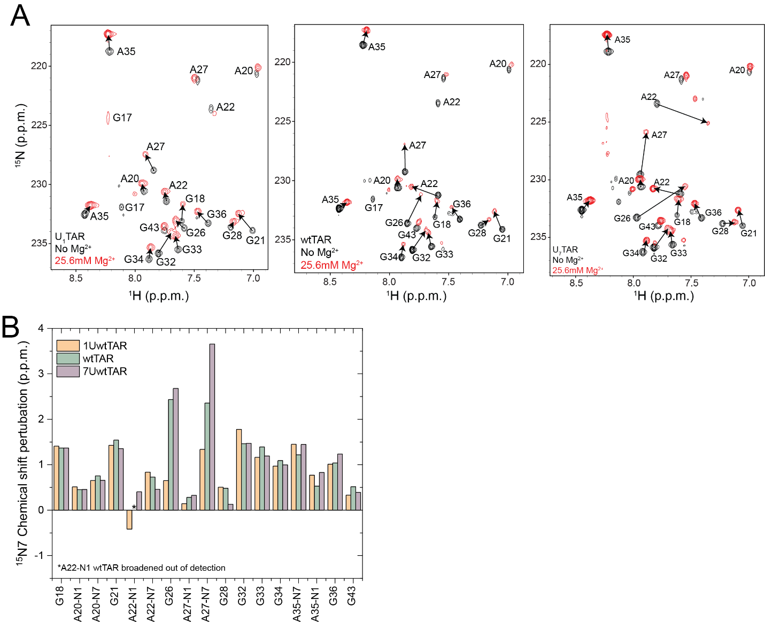
Figure 9: Spectral assignments of (A) U₁, (B) U₄ and (C) U₇TAR. Asterisks represent ambiguous assignments which should be interrupted with caution.

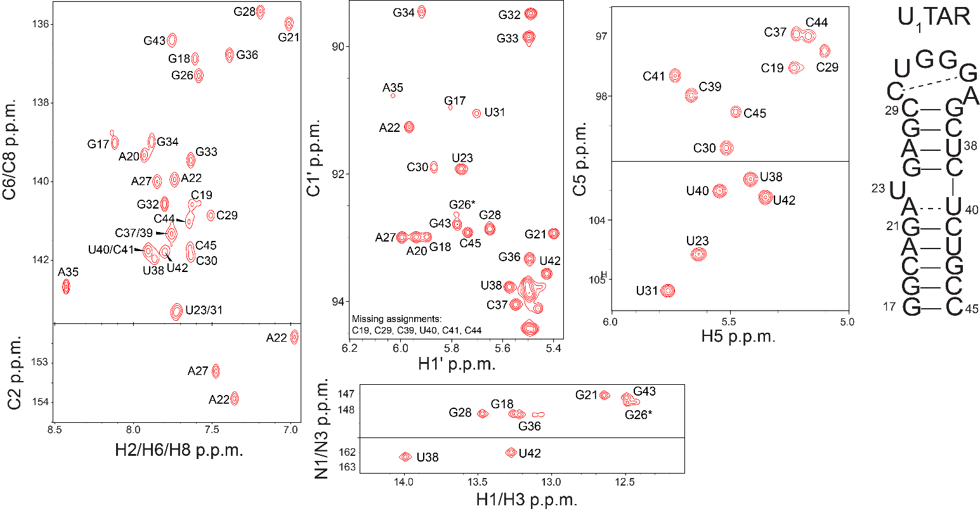
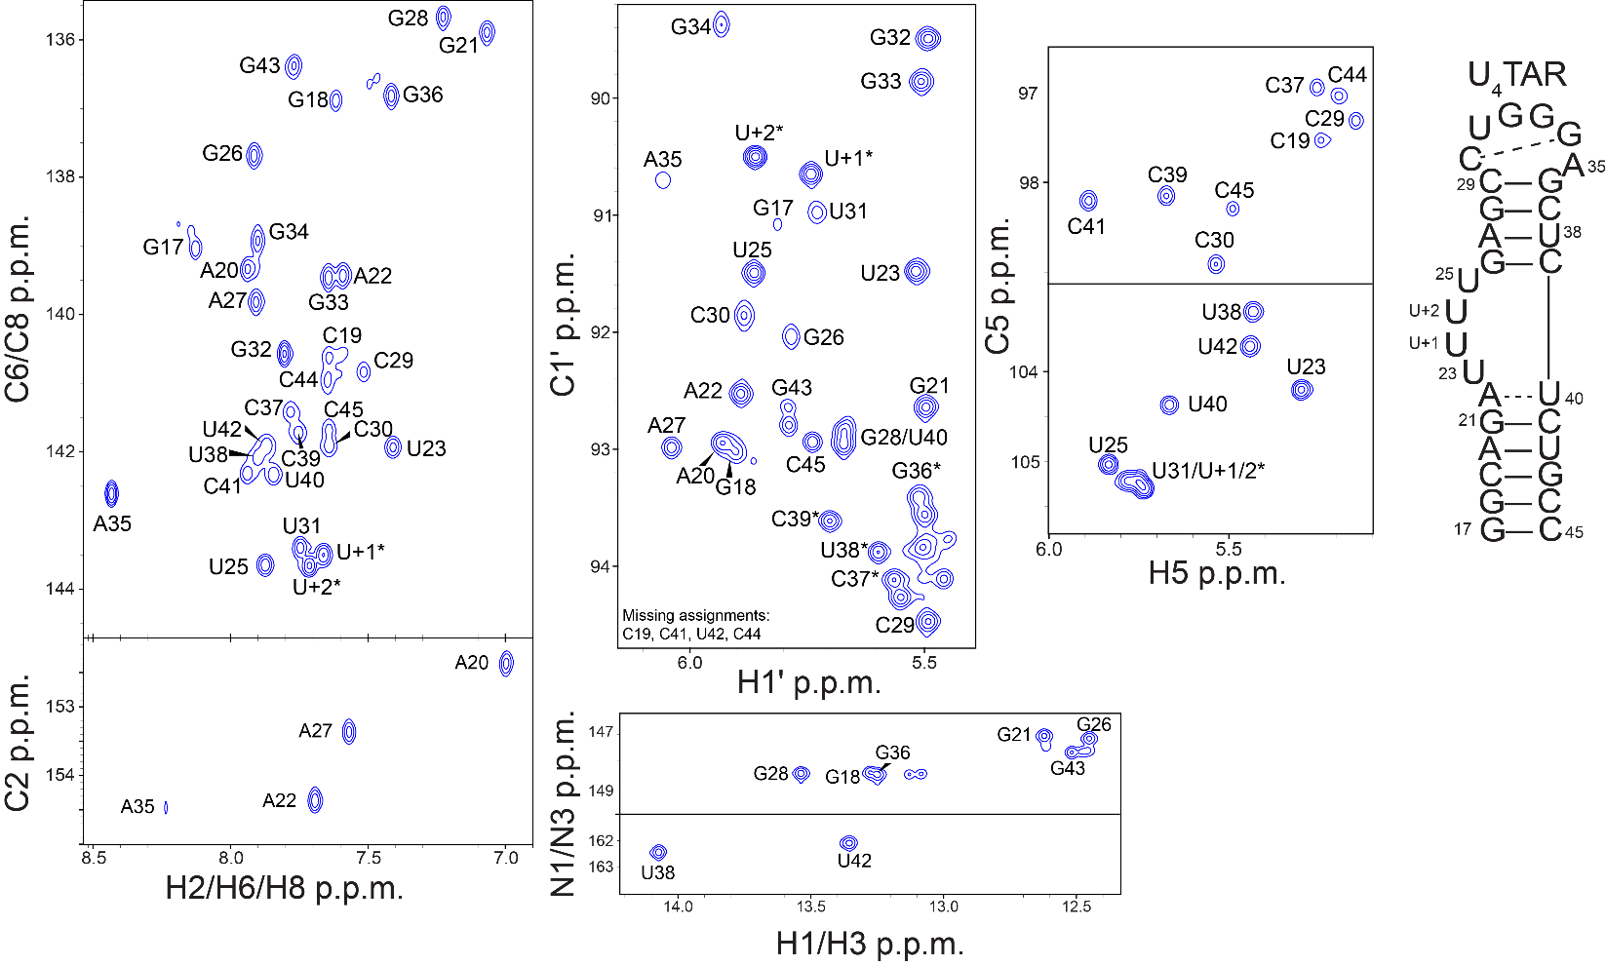
Figure 10 continued: Spectral assignments for U₄TAR
A
B
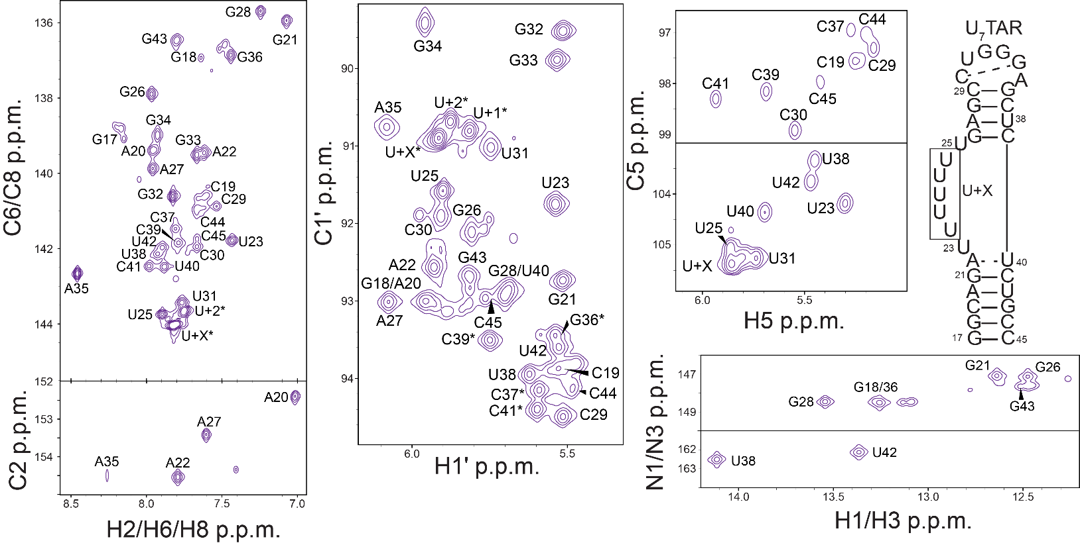
Figure 10 continued: Spectral assignments for U₄TAR
C
Table 1: Fitted Mg_{1/2} data for all two-state fits for TAR variants. See methods for equations and definitions of variables.
U₁TAR
Residue-Atom | Mg_{1/2}  (mM) | Mg_{1/2}  Error (mM) | δ_{free} (p.p.m.) | δ_{free} Error (p.p.m.) | Δω  (p.p.m.) | Δω  Error (p.p.pm)
C19-H6 | 0.239 | 0.024 | 7.625 | 0.002 | 0.087 | 0.002
A20-C8 | 0.337 | 0.074 | 139.318 | 0.008 | -0.182 | 0.007
G21-H8 | 0.410 | 0.035 | 7.016 | 0.002 | 0.111 | 0.003
A22-C8 | 0.516 | 0.089 | 139.951 | 0.008 | -0.222 | 0.006
U23-C6 | 0.375 | 0.045 | 143.249 | 0.008 | 0.266 | 0.006
G26-H8 | 0.327 | 0.042 | 7.596 | 0.002 | 0.073 | 0.002
G26-C8 | 0.267 | 0.032 | 137.307 | 0.008 | 0.312 | 0.008
A27-H8 | 0.195 | 0.022 | 7.850 | 0.002 | 0.0754 | 0.003
U31-C6 | 0.601 | 0.070 | 143.255 | 0.008 | 0.314 | 0.006
G32-H8 | 1.101 | 0.094 | 7.809 | 0.002 | -0.106 | 0.001
G33-C8 | 1.13 | 0.12 | 139.510 | 0.008 | 0.341 | 0.005
G34-C8 | 0.977 | 0.082 | 139.205 | 0.008 | -0.417 | 0.005
A35-C8 | 2.59 | 0.17 | 142.799 | 0.011 | -0.732 | 0.006
G36-H8 | 0.310 | 0.027 | 7.386 | 0.002 | 0.098 | 0.003
C37-C6 | 0.407 | 0.040 | 141.302 | 0.008 | 0.295 | 0.006
C37-H6 | 0.416 | 0.031 | 7.753 | 0.002 | 0.112 | 0.003
U38-H6 | 0.281 | 0.028 | 7.867 | 0.002 | 0.093 | 0.003
U42-H6 | 0.291 | 0.022 | 7.803 | 0.002 | 0.122 | 0.002

U₂TAR
Residue-Atom | Mg_{1/2}  (mM) | Mg_{1/2}  Error (mM) | δ_{free} (p.p.m.) | δ_{free} Error (p.p.m.) | Δω  (p.p.m.) | Δω  Error (p.p.pm)
C19-H6 | 0.332 | 0.037 | 7.628 | 0.002 | 0.091 | 0.002
A20-C8 | 0.311 | 0.079 | 139.305 | 0.010 | -0.197 | 0.009
G21-H8 | 0.355 | 0.029 | 7.037 | 0.002 | 0.135 | 0.002
A22-H2 | 0.109 | 0.018 | 7.457 | 0.003 | -0.058 | 0.002
A22-H8 | 0.103 | 0.012 | 7.737 | 0.003 | 0.081 | 0.003
U23-H6 | 0.159 | 0.013 | 7.632 | 0.003 | 0.122 | 0.002
U23-C6 | 0.0962 | 0.0081 | 143.254 | 0.010 | 0.458 | 0.010
G26-C8 | 0.35 | 0.063 | 137.626 | 0.010 | 0.246 | 0.009
G28-H8 | 1.01 | 0.14 | 7.269 | 0.003 | -0.083 | 0.002
U31-C6 | 0.850 | 0.096 | 143.204 | 0.010 | 0.345 | 0.007
G32-H8 | 1.11 | 0.14 | 7.808 | 0.003 | -0.099 | 0.002
G33-C8 | 0.70 | 0.17 | 139.566 | 0.010 | 0.257 | 0.008
G34-C8 | 0.769 | 0.077 | 139.217 | 0.010 | -0.420 | 0.007
A35-C8 | 1.74 | 0.13 | 142.805 | 0.012 | -0.668 | 0.006
G36-C8 | 0.411 | 0.067 | 136.655 | 0.010 | 0.232 | 0.008
G36-H8 | 0.344 | 0.042 | 7.381 | 0.002 | 0.086 | 0.002
C37-H6 | 0.371 | 0.034 | 7.733 | 0.002 | 0.111 | 0.002
C37-C6 | 0.328 | 0.055 | 141.294 | 0.010 | 0.248 | 0.008
U38-H6 | 0.268 | 0.028 | 7.853 | 0.002 | 0.092 | 0.002
U40-C6 | 0.306 | 0.036 | 141.814 | 0.010 | 0.280 | 0.008
C41-H6 | 0.318 | 0.042 | 7.917 | 0.003 | 0.084 | 0.002
U42-H6 | 0.278 | 0.029 | 7.853 | 0.003 | 0.101 | 0.002

wtTAR
Residue-Atom | Mg_{1/2}  (mM) | Mg_{1/2}  Error (mM) | δ_{free} (p.p.m.) | δ_{free} Error (p.p.m.) | Δω  (p.p.m.) | Δω  Error (p.p.pm)
C19 H6 | 0.73 | 0.18 | 7.588 | 0.006 | 0.124 | 0.004
G21 H8 | 0.59 | 0.31 | 7.054 | 0.006 | 0.065 | 0.005
A22 H2 | 0.271 | 0.076 | 7.608 | 0.006 | -0.099 | 0.005
A22 H8 | 0.186 | 0.022 | 7.615 | 0.006 | 0.214 | 0.006
A22 C8 | 0.128 | 0.016 | 139.537 | 0.027 | 0.583 | 0.023
U23 H6 | 0.213 | 0.019 | 7.421 | 0.006 | 0.291 | 0.006
U23 C6 | 0.221 | 0.017 | 142.068 | 0.025 | 1.330 | 0.023
C24 C6 | 0.72 | 0.25 | 143.250 | 0.024 | 0.312 | 0.018
U25 C6 | 0.180 | 0.031 | 143.189 | 0.026 | 0.542 | 0.022
G26 C8 | 0.307 | 0.076 | 137.574 | 0.024 | 0.457 | 0.021
G26 H8 | 0.243 | 0.065 | 7.854 | 0.006 | -0.109 | 0.006
G28 H8 | 0.73 | 0.48 | 7.233 | 0.006 | -0.067 | 0.005
U31-H6 | 0.082 | 0.025 | 7.752 | 0.007 | 0.072 | 0.006
G32 H8 | 1.11 | 0.32 | 7.811 | 0.006 | -0.110 | 0.004
G33 C8 | 1.74 | 0.70 | 139.565 | 0.028 | 0.324 | 0.015
G34 C8 | 0.47 | 0.12 | 139.253 | 0.024 | -0.492 | 0.021
A35 H8 | 1.09 | 2.12 | 8.430 | 0.008 | -0.060 | 0.005
A35 C8 | 1.76 | 0.40 | 142.736 | 0.030 | -0.616 | 0.016
G36 C8 | 0.34 | 0.16 | 136.712 | 0.024 | 0.231 | 0.020
G36 H8 | 0.37 | 0.12 | 7.404 | 0.006 | 0.079 | 0.005
C37 H6 | 0.49 | 0.15 | 7.752 | 0.006 | 0.093 | 0.005
C39 C6 | 0.267 | 0.091 | 141.518 | 0.025 | -0.338 | 0.022
U40 C6 | 0.195 | 0.055 | 141.913 | 0.025 | -0.380 | 0.023
U40 H6 | 0.261 | 0.097 | 7.827 | 0.006 | 0.073 | 0.005
C41 C6 | 0.148 | 0.039 | 142.2994 | 0.0263 | -0.388 | 0.024
U42 H6 | 0.28 | 0.11 | 7.8637 | 0.0062 | 0.077 | 0.006

U₄TAR
Residue-Atom | Mg_{1/2}  (mM) | Mg_{1/2}  Error (mM) | δ_{free} (p.p.m.) | δ_{free} Error (p.p.m.) | Δω  (p.p.m.) | Δω  Error (p.p.pm)
C19 H6 | 0.355 | 0.067 | 7.641 | 0.005 | 0.081 | 0.004
C19 C6 | 0.071 | 0.087 | 140.622 | 0.022 | -0.094 | 0.021
A20 C8 | 0.384 | 0.182 | 139.326 | 0.018 | -0.217 | 0.016
A22 H2 | 0.246 | 0.015 | 7.714 | 0.005 | -0.280 | 0.004
A22 H8 | 0.254 | 0.018 | 7.595 | 0.005 | 0.241 | 0.004
A22 C8 | 0.208 | 0.020 | 139.443 | 0.019 | 0.662 | 0.016
U23 H6 | 0.259 | 0.013 | 7.406 | 0.005 | 0.334 | 0.004
U23 C6 | 0.254 | 0.010 | 141.887 | 0.019 | 1.829 | 0.016
U+2 H6 | 0.313 | 0.043 | 7.716 | 0.005 | 0.119 | 0.004
U+1 C6 | 0.232 | 0.034 | 143.498 | 0.018 | 0.492 | 0.016
U25 C6 | 0.222 | 0.038 | 143.629 | 0.019 | 0.367 | 0.016
U+2 C6 | 0.435 | 0.092 | 143.649 | 0.018 | 0.346 | 0.014
U+1 H6 | 0.198 | 0.019 | 7.664 | 0.005 | 0.171 | 0.004
U25 H6 | 1.553 | 0.469 | 7.880 | 0.005 | -0.060 | 0.003
G26 C8 | 0.300 | 0.085 | 137.691 | 0.019 | 0.282 | 0.016
G26 H8 | 0.329 | 0.021 | 7.936 | 0.005 | -0.287 | 0.004
A27C2 | 0.167 | 41.261 | 7.573 | 0.110 | -0.055 | 0.017
G28 H8 | 0.735 | 0.214 | 7.238 | 0.005 | -0.080 | 0.004
U31 C6 | 0.878 | 0.171 | 143.253 | 0.018 | 0.388 | 0.013
G32 H8 | 1.076 | 0.233 | 7.817 | 0.005 | -0.112 | 0.003
G33 C8 | 1.493 | 0.429 | 139.537 | 0.021 | 0.355 | 0.013
G34 C8 | 0.668 | 0.118 | 139.225 | 0.018 | -0.450 | 0.013
A35 H8 | 1.521 | 0.751 | 8.443 | 0.006 | -0.073 | 0.003
A35 C8 | 2.143 | 0.329 | 142.761 | 0.023 | -0.650 | 0.012
G36 H8 | 0.453 | 0.135 | 7.412 | 0.005 | 0.062 | 0.004
C37 H6 | 0.507 | 0.115 | 7.767 | 0.004 | 0.085 | 0.004
C39 C6 | 0.256 | 0.035 | 141.748 | 0.019 | -0.528 | 0.017
U40 C6 | 0.267 | 0.036 | 142.344 | 0.019 | -0.564 | 0.016
U40 H6 | 0.423 | 0.108 | 7.845 | 0.004 | 0.074 | 0.004
C41 C6 | 0.164 | 0.033 | 142.346 | 0.020 | -0.337 | 0.017
C41 H6 | 0.253 | 0.072 | 7.945 | 0.005 | 0.070 | 0.004
U42 H6 | 0.270 | 0.092 | 7.875 | 0.005 | 0.061 | 0.004

U₇TAR
Residue-Atom | Mg_{1/2}  (mM) | Mg_{1/2}  Error (mM) | δ_{free} (p.p.m.) | δ_{free} Error (p.p.m.) | Δω  (p.p.m.) | Δω  Error (p.p.pm)
C19-H6 | 0.356 | 0.062 | 7.587 | 0.006 | 0.134 | 0.005
A20-C8 | 0.350 | 0.282 | 139.334 | 0.025 | -0.202 | 0.022
A22-C8 | 0.317 | 0.036 | 139.428 | 0.025 | 0.758 | 0.020
A22-C2 | 0.197 | 0.068 | 154.442 | 0.026 | -0.313 | 0.024
A22-H2 | 0.290 | 0.021 | 7.788 | 0.006 | -0.331 | 0.005
A22-H8 | 0.319 | 0.032 | 7.604 | 0.006 | 0.237 | 0.005
U23-H6 | 0.280 | 0.019 | 7.411 | 0.006 | 0.364 | 0.005
U23-C6 | 0.306 | 0.014 | 141.715 | 0.025 | 2.099 | 0.021
U25-C6 | 0.357 | 0.076 | 143.673 | 0.025 | 0.362 | 0.019
U+2-H6 | 0.236 | 0.047 | 7.732 | 0.007 | 0.112 | 0.006
U+2-C6 | 0.273 | 0.051 | 143.600 | 0.025 | 0.437 | 0.020
G26-C8 | 0.518 | 0.259 | 137.871 | 0.025 | 0.307 | 0.022
G26-H8 | 0.386 | 0.022 | 7.969 | 0.006 | -0.424 | 0.005
A27-C8 | 0.437 | 0.131 | 139.817 | 0.025 | 0.378 | 0.020
G28-H8 | 0.734 | 0.196 | 7.236 | 0.006 | -0.113 | 0.005
U31-C6 | 0.606 | 0.154 | 143.246 | 0.025 | 0.372 | 0.018
G32-H8 | 1.185 | 0.319 | 7.819 | 0.007 | -0.120 | 0.004
G33-C8 | 2.678 | 1.008 | 139.539 | 0.035 | 0.398 | 0.015
G34-C8 | 0.569 | 0.093 | 139.290 | 0.025 | -0.546 | 0.018
A35-C8 | 2.076 | 0.489 | 142.778 | 0.033 | -0.625 | 0.016
A35-H8 | 1.406 | 1.027 | 8.449 | 0.008 | -0.072 | 0.005
G36-C8 | 0.331 | 0.128 | 136.720 | 0.025 | 0.236 | 0.020
C37-H6 | 0.514 | 0.161 | 7.773 | 0.006 | 0.087 | 0.005
C39-C6 | 0.276 | 0.055 | 141.820 | 0.025 | -0.509 | 0.022
U40-C6 | 0.295 | 0.062 | 142.444 | 0.025 | -0.519 | 0.022
C41-C6 | 0.204 | 0.051 | 142.446 | 0.026 | -0.389 | 0.023

25µM wtTAR in buffer without EDTA
Residue-Atom | Mg_{1/2}  (mM) | Mg_{1/2}  Error (mM) | δ_{free} (p.p.m.) | δ_{free} Error (p.p.m.) | Δω  (p.p.m.) | Δω  Error (p.p.pm)
C19 H6 | 0.344 | 0.041 | 7.594 | 0.004 | 0.120 | 0.003
A20-C8 | 0.312 | 0.153 | 139.308 | 0.016 | -0.193 | 0.014
G21 H8 | 0.560 | 0.166 | 7.050 | 0.004 | 0.070 | 0.003
A22 H2 | 0.139 | 0.036 | 7.572 | 0.004 | -0.062 | 0.004
A22 H8 | 0.221 | 0.015 | 7.619 | 0.004 | 0.208 | 0.003
A22 C8 | 0.156 | 0.017 | 139.568 | 0.016 | 0.524 | 0.014
U23 H6 | 0.219 | 0.012 | 7.446 | 0.004 | 0.264 | 0.003
U23 C6 | 0.280 | 0.016 | 142.192 | 0.016 | 1.271 | 0.014
C24 C6 | 0.495 | 0.113 | 143.363 | 0.015 | 0.372 | 0.013
U25 C6 | 0.138 | 0.017 | 143.235 | 0.017 | 0.395 | 0.014
G26 C8 | 0.302 | 0.048 | 137.608 | 0.016 | 0.423 | 0.014
G26 H8 | 0.212 | 0.045 | 7.824 | 0.004 | -0.082 | 0.004
G28 H8 | 0.766 | 0.481 | 7.219 | 0.004 | -0.055 | 0.003
U31-H6 | 1.837 | 1.726 | 7.744 | 0.005 | -0.036 | 0.003
G32 H8 | 1.308 | 0.293 | 7.796 | 0.004 | -0.099 | 0.003
G33 C8 | 1.335 | 0.260 | 139.493 | 0.016 | 0.390 | 0.009
G34 C8 | 0.533 | 2.794 | 138.893 | 0.024 | -0.144 | 0.018
A35 C8 | 2.858 | 0.643 | 142.571 | 0.024 | -0.484 | 0.009
G36 C8 | 0.176 | 0.075 | 136.799 | 0.016 | 0.142 | 0.013
G36 H8 | 0.333 | 0.081 | 7.413 | 0.004 | 0.066 | 0.003
C37 H6 | 0.334 | 0.087 | 7.774 | 0.004 | 0.068 | 0.003
C39 C6 | 0.247 | 0.055 | 141.476 | 0.016 | -0.294 | 0.014
U40 C6 | 0.216 | 0.039 | 141.878 | 0.016 | -0.340 | 0.014
U40 H6 | 0.226 | 0.053 | 7.831 | 0.004 | 0.064 | 0.003
C41 C6 | 0.146 | 0.026 | 142.242 | 0.016 | -0.330 | 0.014
U42 H6 | 0.270 | 0.064 | 7.865 | 0.004 | 0.072 | 0.003

0.3 mM wtTAR
Residue-Atom | Mg_{1/2}  (mM) | Mg_{1/2}  Error (mM) | δ_{free} (p.p.m.) | δ_{free} Error (p.p.m.) | Δω  (p.p.m.) | Δω  Error (p.p.pm)
C19 H6 | 0.278 | 0.038 | 7.615 | 0.005 | 0.100 | 0.004
A20 C8 | 0.456 | 0.168 | 139.347 | 0.020 | -0.234 | 0.017
G21 H8 | 0.573 | 0.150 | 7.035 | 0.005 | 0.075 | 0.004
A22 H2 | 0.269 | 0.054 | 7.591 | 0.005 | -0.092 | 0.005
A22 H8 | 0.289 | 0.018 | 7.559 | 0.005 | 0.270 | 0.005
A22 C8 | 0.257 | 0.021 | 139.412 | 0.021 | 0.720 | 0.018
U23 H6 | 0.303 | 0.014 | 7.359 | 0.006 | 0.357 | 0.005
U23 C6 | 0.318 | 0.013 | 141.806 | 0.021 | 1.636 | 0.019
U23 H1' | 0.294 | 0.060 | 5.530 | 0.019 | 0.312 | 0.017
U23 C1' | 0.103 | 0.017 | 90.968 | 0.022 | -0.286 | 0.019
C24 C6 | 0.242 | 0.043 | 143.289 | 0.021 | 0.333 | 0.018
U25 C6 | 0.353 | 0.040 | 143.100 | 0.021 | 0.662 | 0.018
G26 C8 | 0.367 | 0.048 | 137.529 | 0.021 | 0.533 | 0.018
G26 H8 | 0.333 | 0.050 | 7.857 | 0.005 | -0.124 | 0.005
G28 H8 | 0.925 | 0.393 | 7.224 | 0.005 | -0.067 | 0.004
G32 H8 | 1.298 | 0.259 | 7.806 | 0.005 | -0.118 | 0.003
G33 C8 | 1.252 | 0.277 | 139.465 | 0.020 | 0.434 | 0.014
G34 C8 | 0.999 | 0.889 | 138.937 | 0.021 | -0.185 | 0.016
A35 C8 | 2.602 | 0.564 | 142.611 | 0.025 | -0.510 | 0.013
G36 H8 | 0.382 | 0.082 | 7.397 | 0.005 | 0.076 | 0.004
G36 C8 | 0.281 | 0.098 | 136.794 | 0.021 | 0.190 | 0.018
C37 H6 | 0.422 | 0.092 | 7.760 | 0.005 | 0.081 | 0.004
C39 C6 | 0.354 | 0.067 | 141.555 | 0.021 | -0.376 | 0.018
U40 C6 | 0.325 | 0.049 | 141.966 | 0.021 | -0.441 | 0.018
U40 H6 | 0.290 | 0.062 | 7.813 | 0.005 | 0.083 | 0.005
C41 C6 | 0.253 | 0.037 | 142.361 | 0.022 | -0.472 | 0.019
U42 H6 | 0.354 | 0.069 | 7.847 | 0.005 | 0.093 | 0.004

Table 2: Fitted parameters and errors for two site binding even on A22-C8 of U₂TAR
Parameter | Value | Error
Mg_{1/2 (1)} (mM) | 0.111 | 0.053
Mg_{1/2 (2)} (mM) | 0.60 | 0.21
(p.p.m.) | 139.943 | 0.004
(p.p.m.) | 139.871 | 0.003
(p.p.m.) | 140.063 | 0.020

Table 3: Measured RDCs for U₁ and U₇TAR at low salt conditions (25 mM NaCl, no Mg²⁺). Asterisk indicate ambiguous resonance assignments for U₇TAR bulge.

Residue | Bond Vector | U₁TAR RDCs (Hz) | U₇TAR RDCs (Hz)
G17 | C8H8 | N/A | -25.0
G18 | C8H8 | N/A | 20.4
G18 | C1'H1' | -28.4 | N/A
G18 | N1H1 | -2.8 | N/A
C19 | C5H5 | N/A | -3.9
A20 | C8H8 | 13.2 | 3.5
A20 | C2H2 | 8.2 | 36.5
A20 | C1'H1' | -36.8 | 35.0
G21 | C8H8 | 25.7 | -28.5
G21 | C1'H1' | -33.0 | 36.1
G21 | N1H1 | -12.2 | 21.7
A22 | C8H8 | 22.2 | N/A
A22 | C2H2 | 22.3 | -28.1
A22 | C1'H1' | -2.6 | 24.2
U23 | C6H6 | -1.5 | 10.3
U23 | C1'H1' | -2.4 | -8.3
U23 | C5H5 | 7.0 | -37.5
U+1* | C1'H1' | N/A | -13.9
U+2* | C6H6 | N/A | 6.8
U+2* | C1'H1' | N/A | -5.3
U+X* | C6H6 | N/A | 1.9
U+X | C5H5 | N/A | -9.3
U+X* | C1'H1' | N/A | -4.1
U25 | C6H6 | N/A | 5.0
U25 | C1'H1' | N/A | -33.5
U25 | C5H5 | N/A | -4.8
G26 | C8H8 | 22.5 | 17.6
A27 | C8H8 | 18.0 | 42.7
A27 | C2H2 | 23.2 | 16.8
A27 | C1'H1' | -9.7 | -57.4
G28 | C8H8 | 20.0 | 56.0
G28 | C1'H1' | -14.6 | 16.1
G28 | N1H1 | -10.4 | -22.4
C29 | C5H5 | 17.7 | N/A
C30 | C1'H1' | 1.5 | N/A
C30 | C5H5 | 18.3 | 42.8
U31 | C1'H1' | -7.6 | -15.3
U31 | C5H5 | 7.7 | N/A
G32 | C8H8 | 0.2 | 4.2
G32 | C1'H1' | 3.1 | 5.7
G33 | C8H8 | 9.1 | N/A
G33 | C1'H1' | 1.1 | 0.5
G34 | C8H8 | 16.4 | 28.8
G34 | C1'H1' | 11.1 | 3.0
A35 | C8H8 | 0.3 | 10.0
A35 | C1'H1' | -11.5 | -14.8
G36 | C8H8 | 22.2 | 43.9
G36 | C1'H1' | -33.8 | N/A
G36 | N1H1 | -10.6 | N/A
C37 | C1'H1' | -25.4 | N/A
U38 | C1'H1' | -16.3 | N/A
U38 | C5H5 | 22.9 | 39.4
U38 | N3H3 | -8.1 | -23.0
C39 | C5H5 | 20.2 | 48.2
C39 | C1'H1' | N/A | 35.7
U40 | C5H5 | 16.3 | 33.0
C41 | C6H6 | N/A | -44.9
C41 | C5H5 | 19.4 | N/A
U42 | C6H6 | N/A | 11.1
G42 | C1'H1' | 2.7 | N/A
U42 | C5H5 | 22.9 | -30.7
U42 | N3H3 | -9.5 | 9.6
G43 | C8H8 | 13.3 | 11.3
G43 | C1'H1' | -2.6 | N/A
C44 | C5H5 | N/A | -18.1
C45 | C1'H1' | -13.9 | N/A
C45 | C5H5 | 13.3 | 21.4

Table 4: Measured RDCs for U₁, wt, and U₇TAR at 25 mM NaCl and 3 mM Mg²⁺. Asterisk indicate ambiguous resonance assignments for U₇TAR bulge.
Assignment | Bond Vector | U₁TAR RDCs  (Hz) | wtTAR RDCs (Hz) | U₇TAR RDCs (Hz)
G17 | C8H8 | N/A | 2.8 | N/A
G18 | C1'H1' | N/A | -40.4 | N/A
G18 | N1H1 | -14.0 | N/A | -12.2
C19 | C5H5 | -2.8 | -3.8 | -5.3
A20 | C8H8 | 14.8 | 18.8 | 20.4
A20 | C2H2 | 9.3 | 12.8 | 5.0
A20 | C1'H1' | -35.8 | -40.5 | N/A
G21 | C8H8 | 19.2 | 26.7 | 26.0
G21 | C1'H1' | -32.4 | -26.7 | -13.9
G21 | N1H1 | -11.4 | -14.8 | -10.1
A22 | C8H8 | 23.4 | 23.5 | 15.3
A22 | C2H2 | 18.0 | 20.5 | 24.4
A22 | C1'H1' | -5.4 | 4.3 | -11.6
U23 | C6H6 | N/A | 7.4 | -4.5
U23 | C1'H1' | -4.4 | -0.1 | -4.8
U23 | C5H5 | 3.2 | 2.2 | -2.6
C24 | C1'H1' | N/A | -12.0 | N/A
C24 | C5H5 | N/A | -0.7 | N/A
U25 | C6H6 | N/A | 1.7 | N/A
U25 | C1'H1' | N/A | 4.7 | N/A
U25 | C5H5 | N/A | 5.1 | 9.3
U+X* | C5H5 | N/A | N/A | -1.0
U+X* | C1'H1' | N/A | N/A | -2.9
G26 | C8H8 | 24.7 | 25.1 | 9.2
G26 | N1H1 | -7.7 | -12.1 | -2.3
A27 | C8H8 | 23.0 | 19.8 | 6.3
A27 | C2H2 | 22.7 | 22.2 | 6.9
A27 | C1'H1' | -10.2 | -18.0 | -14.9
G28 | C8H8 | 18.5 | 21.1 | 13.2
G28 | C1'H1' | -13.3 | N/A | -18.2
G28 | N1H1 | -10.9 | -16.7 | -11.6
C29 | C6H6 | 17.0 | 26.3 | 29.8
C29 | C1'H1' | -10.8 | -14.4 | -11.7
C29 | C5H5 | 16.3 | 19.9 | 7.6
C30 | C6H6 | 15.2 | N/A | N/A
C30 | C1'H1' | 1.8 | -7.8 | 7.6
C30 | C5H5 | 15.8 | 23.7 | 16.8
U31 | C6H6 | -7.5 | -7.6 | N/A
U31 | C1'H1' | -5.8 | -7.1 | -2.0
U31 | C5H5 | 4.5 | 8.3 | N/A
G32 | C8H8 | 1.7 | -1.2 | N/A
G32 | C1'H1' | 3.0 | 1.2 | -0.1
G33 | C8H8 | 12.5 | 11.8 | 13.4
G33 | C1'H1' | 1.5 | -1.7 | -4.8
G34 | C8H8 | 19.4 | 19.8 | 18.1
G34 | C1'H1' | 10.4 | 11.0 | 1.2
A35 | C8H8 | 1.6 | 0.7 | -0.6
A35 | C1'H1' | -9.8 | -12.5 | -8.1
G36 | C8H8 | 23.1 | 25.1 | 27.6
G36 | C1'H1' | -30.6 | N/A | N/A
G36 | N1H1 | -10.2 | -13.5 | N/A
C37 | C6H6 | 14.0 | 23.1 | 21.1
C37 | C1'H1' | -16.7 | -19.5 | N/A
C37 | C5H5 | N/A | 17.8 | 18.8
U38 | C6H6 | 20.0 | 18.8 | N/A
U38 | C1'H1' | -16.2 | -16.3 | N/A
U38 | C5H5 | 13.8 | 23.6 | 27.8
U38 | N3H3 | -8.4 | -11.1 | N/A
C39 | C6H6 | 17.0 | 19.6 | 4.1
C39 | C1'H1' | -25.3 | -29.2 | -6.2
C39 | C5H5 | 14.1 | 17.9 | 20.6
U40 | C6H6 | 21.7 | N/A | N/A
U40 | C5H5 | 16.5 | 16.8 | N/A
U40 | C1'H1' | N/A | N/A | -20.9
C41 | C6H6 | N/A | 23.8 | 22.5
C41 | C5H5 | 20.2 | 24.5 | 1.5
C41 | C1'H1' | N/A | N/A | -10.0
U42 | C6H6 | 17.9 | 21.8 | N/A
U42 | C5H5 | 19.4 | 24.3 | 11.5
U42 | N3H3 | -9.4 | -13.8 | -12.2
G43 | C8H8 | 13.6 | 16.3 | 18.8
G43 | C1'H1' | N/A | 7.1 | 5.7
G43 | N1H1 | -10.0 | -12.2 | N/A
C44 | C6H6 | N/A | 16.4 | N/A
C44 | C5H5 | N/A | 30.7 | N/A
C45 | C1'H1' | N/A | -28.6 | N/A
C45 | C5H5 | N/A | 17.1 | N/A

Works cited

Bailor MH, Musselman C, Hansen AL, Gulati K, Patel DJ, Al-Hashimi HM. 2007. Characterizing the relative orientation and dynamics of RNA A-form helices using NMR residual dipolar couplings. Nat Protoc 2: 1536–1546.
Berman HM, Westbrook J, Feng Z, Gilliland G, Bhat TN, Weissig H, Shindyalov IN, Bourne PE. 2000. The Protein Data Bank. Nucleic Acids Res 28: 235–42.
Brodsky AS, Williamson JR. 1997. Solution Structure of the HIV-2 TAR- Argininamide Complex. J Mol Biol 267: 624–639.
Durney MA, D’Souza VM. 2010. Preformed Protein-binding Motifs in 7SK snRNA: Structural and Thermodynamic Comparisons with Retroviral TAR. J Mol Biol 404: 555–567.
Hennig M, Williamson JR. 2000. Detection of N-H ... N hydrogen bonding in RNA via scalar couplings in the absence of observable imino proton resonances. Nucleic Acids Res 28: 1585–1593.
Pitt SW, Majumdar A, Serganov A, Patel DJ, Al-Hashimi HM. 2004. Argininamide Binding Arrests Global Motions in HIV-1 TAR RNA: Comparison with Mg2+-induced Conformational Stabilization. J Mol Biol 338: 7–16.
Puglisi JD, Tan R, Calnan BJ, Frankel AD, Williamson JR. 1992. Conformation of the TAR RNA-Arginine Complex by NMR Spectroscopy. Science 257: 76–80.
Robertson MP, Igel H, Baertsch R, Haussler D, Ares M, Scott WG. 2005. The structure of a rigorously conserved RNA element within the SARS virus genome. PLoS Biol 3.
Sathyamoorthy B, Lee J, Kimsey IJ, Ganser LR, Al-Hashimi HM. 2014. Development and application of aromatic [13C, 1H] SOFAST-HMQC NMR experiment for nucleic acids. J Biomol NMR 60: 77–83.

